Armondo Dobbs

Advanced Data Management PA

**Part A:**

**Summarize one real-world business report that can be created from the attached Data Sets and Associated Dictionaries.**

With the given database and tables, there are many opportunities for real world business that could be implemented. In this scenario, this report will be looking at how many sales employees have in a given period of time. This information can be useful as businesses can see which employees have the highest performance and can establish an employee rewards program to incentivize more sales or acknowledge our best employees.

**A1: Data used**

The data needed to compile this report will be the staff data and the rental data as the rental information for each employee is what will be needed to determine which employees have the highest performance. Another contributing piece of information could be the store data as well as the number of staff present at each store could correlate to rental sales.

**A2: Identify specific tables**

The specific tables needed from the data set to create the detail and summary reports are the Store, Rental, Address, and Staff tables. The data from these tables based off of the ER diagram will provide enough information to make educated decisions on moving forward within the stores.

**A3: Identify specific fields for detailed and summary reports**

In order to create a detailed report on number of rentals per store it will need:

Rental ID, Staff ID, Rental Date from Rental table

Email, First_name, and Last_Name from Staff table

As for the summary report, it will only need:

Employee full name and total rentals

**A4: Identify transformation field**

A field in the detailed report that will be transformed is the employee first name and last name. These will be combined into one name using concatenation to provide better readability for managers and stakeholders.

**A5: Business uses of information**

The detailed report is beneficial for business as it gives business professionals a detailed insight as to exactly how many movie rentals along with which movies are sold by specific employees at any given time. This will help create the rewards incentive for employees as mentioned before or another application could be to give the proper accreditation to employees with the highest numbers and recognize their hard work.

The summary report is just as beneficial as it provides a quick and to the point representation of how many sales employees have between two dates without any redundant data which will help make quick decisions moving forward.

**A6: Refresh frequency**

To get the most out of the data from these reports, they should be refreshed a minimum of once a month but no later than once every business quarter in order to remain relevance to stakeholders so that they can make the necessary changes to policies and maintain the highest level of profit.

**F1: when to run refresh**

As stated above in the summary, the refresh function should be used a minimum of once a month or at least once every business quarter. In order to do this, an admin would implement a time parameter with the query inside for once every thirty days or so to activate the trigger and run the Full_Refresh procedure. This will automate the reports and have them ready whenever they are needed.

**Final Code and Sources**

**Part B and C SQL Code**

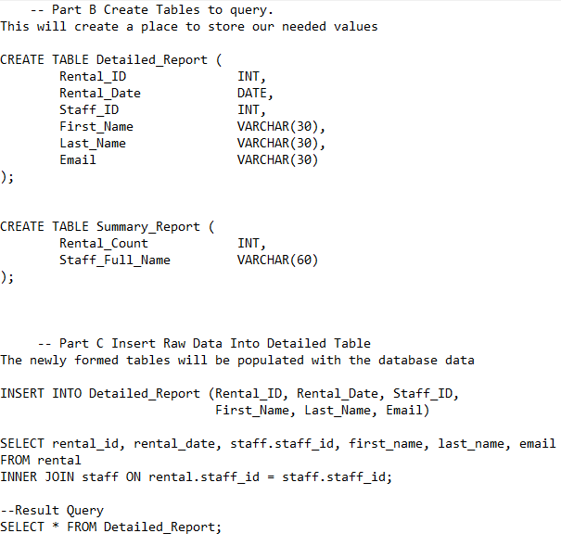

**Part D and E SQL Code**

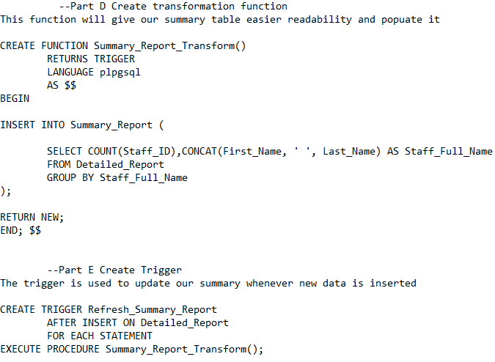

**Part F SQL Code**

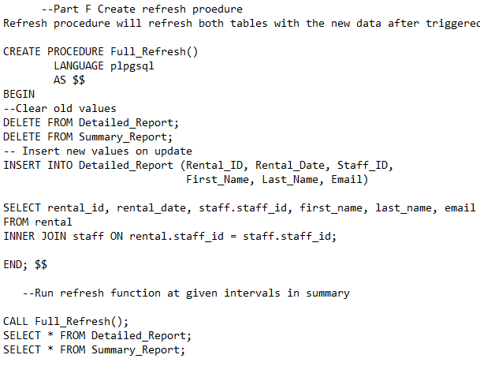

**Web sources -** Record the web sources you used to acquire data or segments of third-party code to support the application if applicable.

-No web sources were used to acquire data or segments of third-party code to support the application.

**Sources -** Acknowledge sources, using in-text citations and references, for content that is quoted, paraphrased, or summarized.

-No content has been quoted, summarized, or paraphrased in this project.